### User Group Settings

Users can be assigned to a user group. When first created, all users are assigned to the Master Users Group by default. HIE Administrators should remain in the Master Users Group. User Group Administrators and all other users may be reassigned to a sub group of the Master Users Group, depending on affiliation.

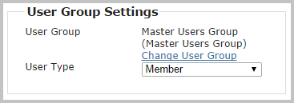

Click **Change User Group** to add the user to a sub group of the Master Users Group (or to reassign a user to the Master Users Group).

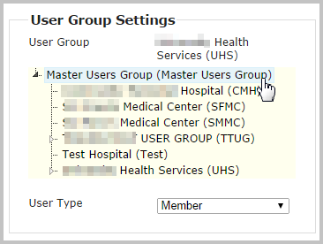

Select the appropriate user group from the list displayed. Once selected, the list will collapse, and a confirmation message will appear.

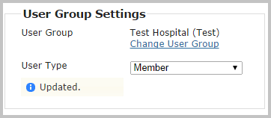

Then, assign a *User Type*. All non-administrators have User Type of **Member** by default. For users who will have an Administrator or User Group Administrator role**,** select **Administrator**.